# Brand Lift Test – Kantar Norms

## Background

Brand lift solution powered by Kantar's Ignite panel. Study results are generated by statistical processing, weighting, and balancing survey responses by ad-exposed test group and non-exposed control group. The lift test aims to evaluate the awareness, consideration and purchase on brand promoted for each non-endemic vertical.

## Brand Lift Test Design and Exploratory Data Analysis

We aim to validate Kantar’s survey standard brand lift solutions and provide new and expedient insights based on the following steps:

1. Any survey results with “Sig level” less than 80% are removed. “Sig level” is the degree of confidence Kantar had on its survey results.

1. We aggregated and applied weighted average on survey response score based on grouping criteria such as “Test Vertical” and “Question Type”.
2. We applied Fisher’s Exact Test for two proportions to determine if the survey lift (positive or negative) is statistically significant

Diagnostic plots of aggregated survey results are as follows:

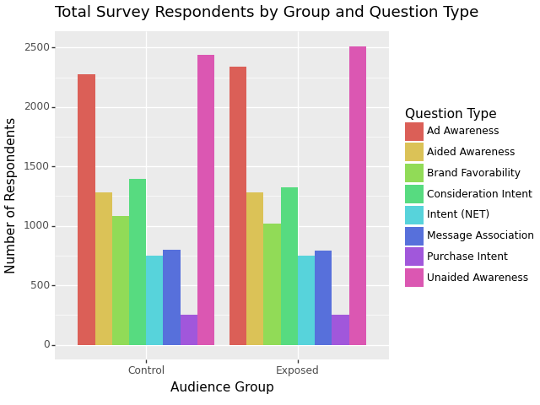

Comments: This survey study has the most respondents in awareness type of questions.

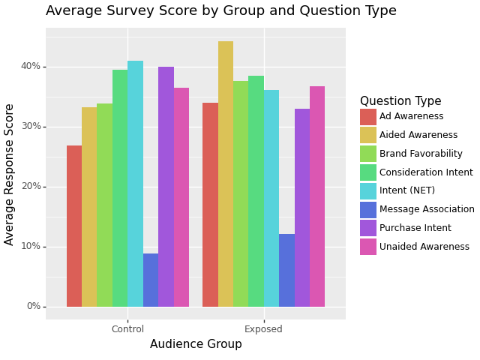

Comments: Aided Awareness type of question appears to have the largest average lift.

## Test Results

Test Vertical: Financial Services

Question Type: Aided Awareness

Lift: 11.05%,

P_value: 1.0069518114934293e-08, Significant

Sample Size (Control: 1280 , Exposed: 1281)

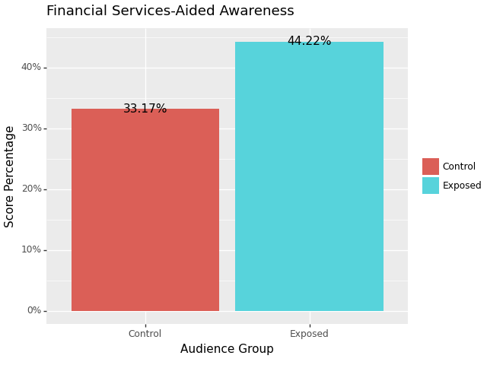

Test Vertical: Financial Services

Question Type: Ad Awareness

Lift: 7.13%,

P_value: 1.7666471491365444e-07, Significant

Sample Size (Control: 2275 , Exposed: 2341)

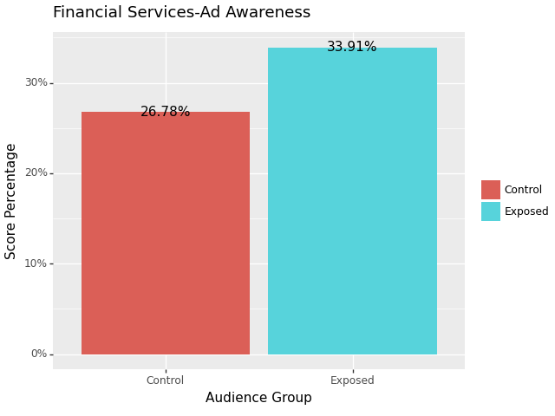

Test Vertical: Financial Services

Question Type: Message Association

Lift: 3.26%,

P_value: 0.03960822442882296, Significant

Sample Size (Control: 801 , Exposed: 794)

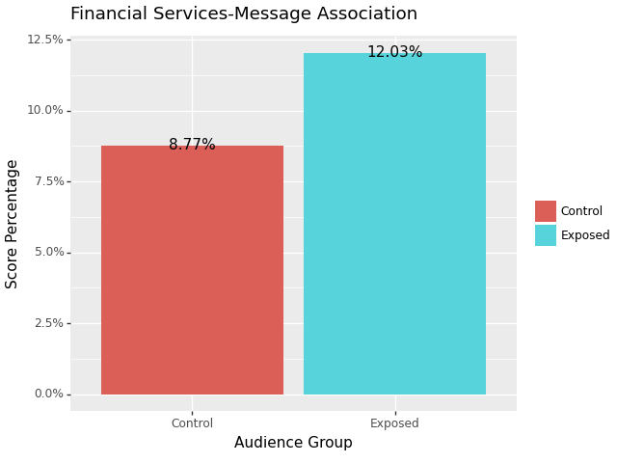

Test Vertical: Financial Services

Question Type: Intent (NET)

Lift: -4.86%,

P_value: 0.05591509390272678, Not Significant

Sample Size (Control: 749 , Exposed: 750)

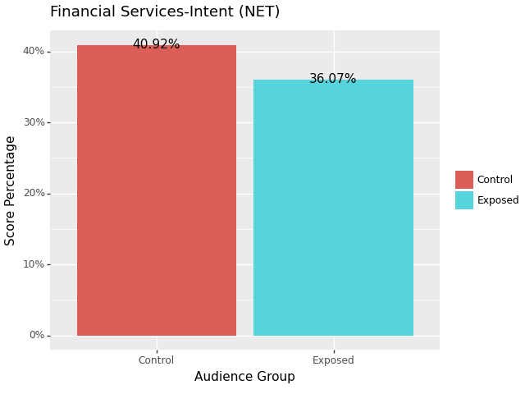

Test Vertical: Financial Services

Question Type: Brand Favorability

Lift: 3.77%,

P_value: 0.07550279740759755, Not Significant

Sample Size (Control: 1081 , Exposed: 1021)

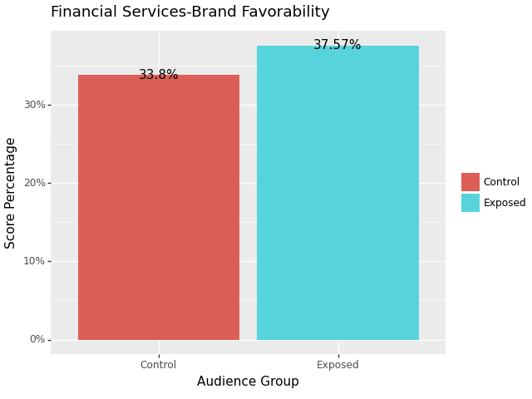

Test Vertical: Financial Services

Question Type: Purchase Intent

Lift: -6.9%,

P_value: 0.11546025936585651, Not Significant

Sample Size (Control: 250 , Exposed: 253)

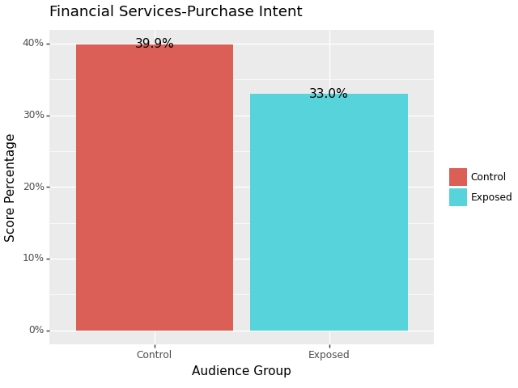

Test Vertical: Financial Services

Question Type: Consideration Intent

Lift: -1.08%,

P_value: 0.5817589470234603, Not Significant

Sample Size (Control: 1396 , Exposed: 1323)

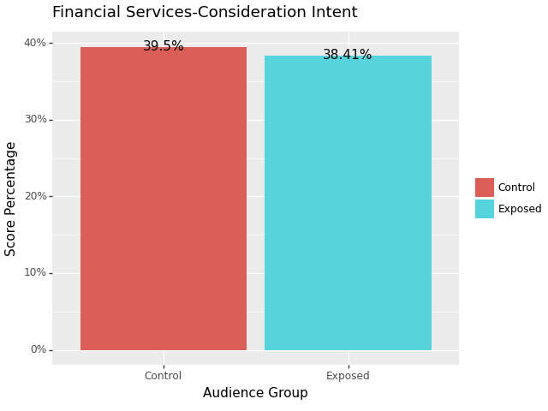

Test Vertical: Financial Services

Question Type: Unaided Awareness

Lift: 0.36%,

P_value: 0.8132876283072272, Not Significant

Sample Size (Control: 2438 , Exposed: 2510)

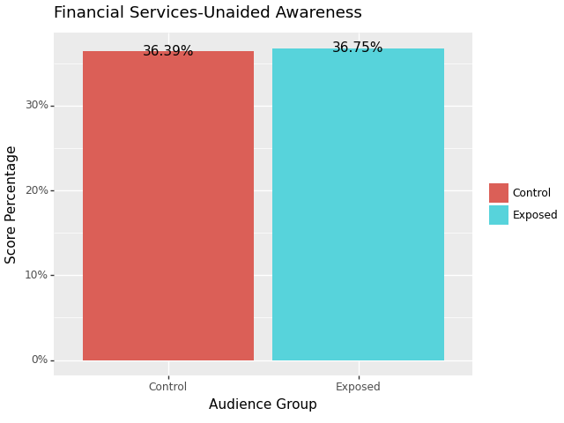

## Summary

Overall, 3 out of 8 question type produces significant lift for Financial Services. The average lift and sample size for the group producing significant results are 7.15% and 2924 (Control:1452, Exposed: 1472), respectively.

